1)User-carlalouisa

ToS-Feedback form is not displayed

2)User-kelley3969

Refer a friend-Rules and conditions apply opens below page

Android displays Prod url

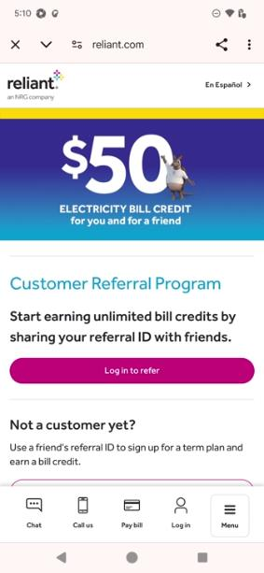

3)User- kaylabridges

OCS-Popup not displayed